Nepal College of Information Technology
Assessment
Fall 2011
Program : BE ELXCE Time : 3 hrs
Semester : Fall (III) FM : 100
Subject : Electronic Devices PM : 50

- Candidates are requested to give their answer as far as practicable in their own words.
- The figure in the margin indicates the full marks
- Attempt ALL question
1. a) Differentiate between linear and non-linear device. Find the piecewise linear model of a Silicon diode with I_{S} = 10⁻¹¹ A and η = 1.6 in the vicinity of operating point I_{D} = 1 mA at 30 °C. 4+4
b) What is reverse recovery time of PN junction diode? Explain its effect in diode switching with appropriate waveform. 7
2. a) Draw the I-V characteristics of a PN junction diode showing forward biased region, reverse biased region and breakdown region. Differentiate between the two types of breakdown observed in PN junction diode. 5+3
b) Refer the circuit diagram below:
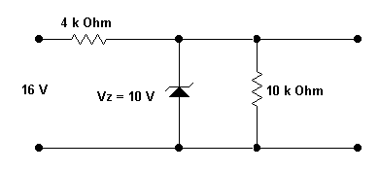 2+2+3
Find
i) The output voltage.
ii) Voltage across R_{s} = 4 KΩ
iii) The current through Zener diode
3. a) Why BJT is said to be bipolar device and JFET as unipolar device? Explain the working principle of an NPN transistor with suitable diagram. 2+5
b) Draw DC load line and locate the operating point of the following BJT circuit. 8
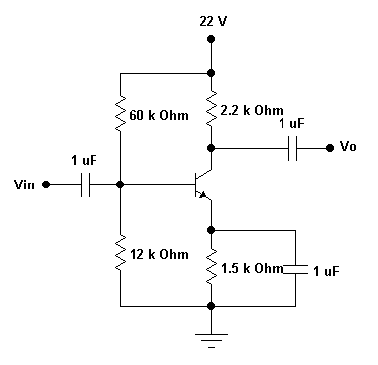
4. a) For the following configuration, find i) r_{e} and ii) voltage gain (A_{v}). 3+4
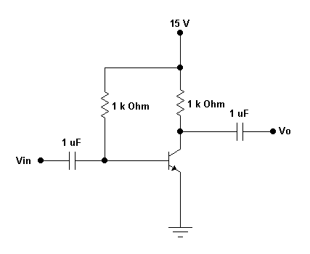
b) The transistor used in the circuit has the following parameters: h_{ie} = 1560 ohm, h_{fe} = 120. Calculate (i) R_{in(s),} (ii) R_{o}, (iii) A_{v} and (iv) A_{i}. 2+2+2+2
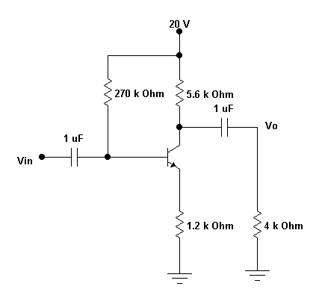
5. a) Describe the construction and working principle of an n-channel JFET with suitable diagrams. 8
b) For the given JFET circuit, find the value of resistance R_{s}. Given: V_{GS} = -2 V. 7
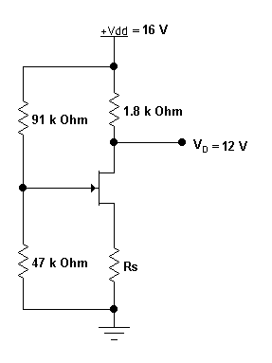
6. a) Explain the working principle of a full wave rectifier using a center tapped transformer. Find an expression for the ripple voltage when a filter capacitor is added in the full wave rectifier circuit. 4+4
b) What do you mean by clippers and clampers? Suggest any one circuit for the purpose of double ended clipping and draw its output waveform with a brief explanation. 2+5
7. Write short notes on: (Any two) 5*2=10
a) Diffusion capacitance and Depletion capacitance
b) High frequency T-model of BJT
c) Ebers Moll model of BJT
d) Thermal runaway and bias compensation

